Water Hammer Test Setup Description

1. Introduction
This document provides a complete description of the water hammer test, including hardware configuration, fluid system architecture, instrumentation layout, nitrogen pressurization system, and flow characterization methodology.

The test stand was originally constructed as a CV stand for a UVM SEED Project and has been modified to support controlled water hammer and priming transient experiments. Deionized water is used as the working fluid as a propellant analog. Rapid valve closure events are used to generate repeatable pressure transients.

2. System Overview

2.1 Functional Description
The test stand is a pressurized open-outlet flow loop. Nitrogen gas pressurizes a supply bottle containing deionized water, driving a steady flow of water through a straight stainless steel test section. Rapid closure of a downstream solenoid valve arrests the flow, generating a water hammer pressure wave that propagates upstream through the test section and is captured by high-frequency pressure transducers at two instrumented branch locations. The upstream solenoid valve can be used independently or in sequence with the downstream valve to generate more complex wave interactions.

The complete fluid path from supply to outlet is:
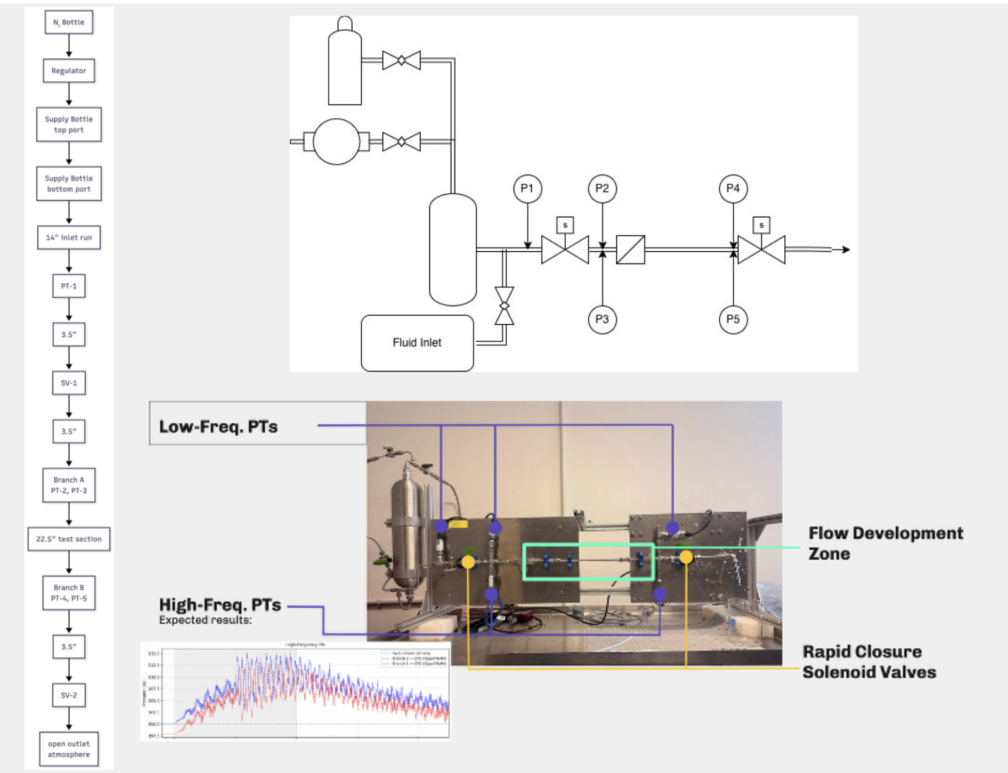

3. Supply Bottle and Nitrogen Pressurization System
The supply bottle serves as the pressurized fluid reservoir and is the primary means of setting initial flow conditions. It has three port connections:

Port | Location | Connection | Function
Port 1 (top) | Bottle head | Vacuum pump | De-aeration of working fluid prior to test runs
Port 2 (top) | Bottle head | N₂ supply regulator output | Pressurization of headspace to drive flow
Port 3 (bottom) | Bottle base | 1/4" SS tubing to test section inlet | Fluid outlet to test section; also used for fill

Nitrogen gas is supplied from a compressed N₂ cylinder through a single-stage pressure regulator. The regulator output connects directly to Port 2 on the supply bottle head, establishing a regulated gas blanket above the liquid surface. The supply pressure is set at the regulator prior to each test run and is verified against the reference pressure gauge mounted on the regulator outlet.

4. Pipe Geometry and Test Section
All fluid-wetted piping is 1/4" OD stainless steel tubing with 0.035" wall thickness, connected throughout using Swagelok fittings.

All dimensions are measured along the centerline of the tubing from the referenced datum. The primary test section is the 22.5" straight run between Branch A and Branch B, which is the instrumented zone used for wave propagation analysis.

Segment | Length (in) | Length (mm)
Inlet run | 14.0 | 356
PT-1 to SV-1 | 3.5 | 89
SV-1 to Branch A | 3.5 | 89
Test section | 22.5 | 572
Branch B to SV-2 | 3.5 | 89
SV-2 to outlet | TBD | TBD
Total (bottle to SV-2) | ~47 | ~1194

The acoustic round-trip time for a pressure wave in the 22.5" test section is approximately 2 × 0.572 m / 1350 m/s ≈ 0.85 ms. This sets the fundamental water hammer period and should be resolvable by the 50 kHz NI cDAQ (sample interval 20 μs).

5. Instrumentation
See the software doc for information on pressure transducer measurements.
ID | Type | Location | DAQ System | Sample Rate
PT-1 | Low-frequency (Omega PX309) | Inlet, 14" from bottle | LabJack T7, AIN0 | 1 kHz
PT-2 | Low-frequency (Omega PX309) | Branch A, upstream | LabJack T7, AIN1 | 1 kHz
PT-3 | PCB Piezotronics 113B03 | Branch A, downstream | NI cDAQ, ai0 | 50 kHz
PT-4 | Low-frequency (Omega PX309) | Branch B, upstream | LabJack T7, AIN2 | 1 kHz
PT-5 | PCB Piezotronics 113B03 | Branch B, downstream | NI cDAQ, ai1 | 50 kHz

Two solenoid valves (SV-1 and SV-2) are installed in the flow pat. SV-2 is the primary water hammer actuator. Rapid energization arrests the flow, generating the pressure transient. SV-1 provides an upstream isolation capability and is largely a remain from the CV test stand.

6. Flow Rate Characterization and Expected Operating Conditions
The test stand does not include a dedicated inline flow meter. Steady-state volumetric flow rate and mean flow velocity are characterized empirically during Series 0A shakedown.

Two methods are used in parallel to cross-validate velocity estimates:
Timed collection: With SV-2 open and steady flow established, fluid is discharged into a graduated container over a measured time interval. Volumetric flow rate Q (mL/s) is calculated directly and converted to mean velocity via the pipe cross-sectional area. This method is accurate but requires a collection phase before the water hammer event.

P-drop inference: The steady-state pressure differential between PT-1 (inlet) and PT-2 (Branch A) is used with the Darcy-Weisbach equation to back-calculate flow velocity.

Supporting calculations are maintained in the companion Excel workbooks (flow_characterization.xlsx). Those workbooks compute Re, friction factor, and expected ΔP across the inlet run as a function of N₂ supply pressure for both methods.

For each supply pressure level in the test matrix, the expected peak transient pressure must be estimated before the run to verify that it falls within the 500-psi range of the pressure transducers. The Excel workbooks will be filled in as shakedown data becomes available.

7. Pressure Transducer Calibration
All five pressure transducers require individual calibration to produce accurate engineering-unit (psi) readings from raw voltage signals.
Calibration status for each transducer is tracked in the table below. Until all calibrations are complete and verified, the _psi columns in DAQ output files should be treated as approximate.

Sensor | Model | Calibration Source | Last Cal. Date | Status
PT-1 | Omega PX309 | TBD | TBD | Pending
PT-2 | Omega PX309 | TBD | TBD | Pending
PT-4 | Omega PX309 | TBD | TBD | Pending
PT-3 | PCB 113B03 | TBD | TBD | Pending
PT-5 | PCB 113B03 | TBD | TBD | Pending

8. Data Acquisition Hardware
Data acquisition is handled by two independent systems operating in parallel, synchronized via a shared digital trigger signal from the solenoid valve command line. Full software documentation is provided in the software document. Hardware details are summarized here for completeness.

System | Hardware | Channels Used | Sample Rate | Role
LabJack T7 | LabJack T7 Pro (USB) | AIN0, AIN1, AIN2 (analog) FIO0 (digital trigger) | 1 kHz | Low-frequency PT-1, PT-2, PT-4; trigger detection
NI cDAQ | NI cDAQ-9174 chassis + module | ai0, ai1 (analog) port0/line0 (digital trigger) | 50 kHz | High-frequency PT-3, PT-5; trigger detection

Both systems are connected to the same laptop or data acquisition PC. The acquisition scripts are launched in separate terminal sessions before each run and are synchronized by the shared hardware trigger signal. See WH-DAQ-001 for full operational details.

9. Known Limitations and Planned Improvements
 | Limitation | Impact
Flow measurement | No inline flow meter | V₀ uncertainty affects CFD boundary condition accuracy.
Calibration | All PT calibration coefficients are placeholders pending calibration (ping Matt K-C) | _psi output columns are approximate/ reference only
Valve closure profile | Solenoid closure time and stroke profile not yet verified | CFD valve boundary condition uses assumed ramp; may not match physical closure.
De-aeration | Vacuum de-aeration iffy | Unknown dissolved gas affects wave speed c and may suppress cavitation.
Wave speed verification | c assumed at 1,350 m/s from literature; not yet measured. | Joukowsky ΔP estimates carry uncertainty until c is confirmed.

